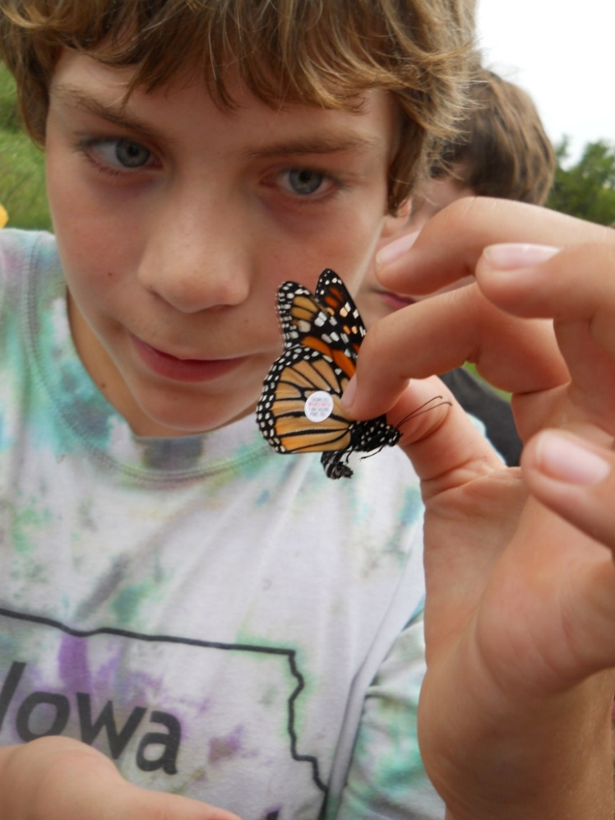

***Osborne Classroom Naturalist Program***

Environmental Education Program Offerings

**1. *Tails***- Learn what animals use their tails for! We will read the book “*Tails*” by Matthew Van Fleet and play a tail matching game. **Grades PS-K**

***2. Wiggly Worms-*** Read the short story, “An Earthworm’s Life”, and then use our senses (sight, touch, smell) to investigate real worms with magnifying glasses. **Grades PS-K**

**3*.The Mitten****-* The Jan Bret book will be read and students will have a chance to become one of the animals in the big mitten! **Grades PS-1**

**4*.Mossy****–* Beautiful Jan Bret book about a Box Turtle. Class will meet a live turtle! **Grades PS-1**

**5. *Sammy Soil or Ruby Raindrop–*** Invite either Sammy or Ruby to visit your class to learn about rain, watersheds, pollution, or soils. **Grades K-2**

**\*6. *Scaly and Slimy -*** A look at the characteristics of reptiles and amphibians. Live animals brought for “hands-on” investigations. **Grades K & up**

**7*. Winter Birds***-Common Iowa birds are featured and binoculars can be used outdoors with the students! **Grades K-8**

**8. *Indian Tales*** *-* Stories were used by the Native Americans to explain the world around them, to teach lessons and to entertain. Students will hear short stories then interpret them. **Grades K-5**

**\*9**. ***Hoo Gives A Hoot?*** - The lifestyle and adaptations of “Nature’s Perfect Mousetraps,”

the owls. **Grades K & up**

***\*10. Tools of the Trade -***Every animal has adaptations that enable their unique lifeways – superb vision, long claws, or even extra senses. Compare animal “tools” with our own in this interactive program. ***1st Grade***

**11. *Incredible Insects* -** What makes an animal an insect, and why “bugs” are important**. Grades 1-4**

**12. *Grossology* -** Nature is Yucky-Learn why as we get up close to things creepy & slimy. **Grades 1-4**

***\* We make every effort to align each program with NGSS. Programs starred have an even higher emphasis.***

**13. *A Second Chance*** - Learn about what extinction and extirpated means. **Dr. Seuss's Lorax** will be read and students will learn about the responsibility they have to the environment! **Grades 2 & up**

**\*14. *Nature’s Web* -** In ecology “Everything is connected.” We’ll take a look at some of the connections between animals and plants and their habitats. **Grade 2 & Up**

**\*15. *Osprey-*** Learn about the adaptations of the Osprey and where it migrates each fall. Students will use their geography knowledge to learn the flight of this bird **Grades 3 & up**

**16. *Snow Detectives -*** Students make animal

tracks out of plaster **Grades 3 &up**

**\*17. *Winter CSI*–** Students use tracking and inquiry skills to investigate signs left behind by animals in the winter. **Grades 3 & up** *Could do outside*

**18. *Symbols of Iowa–*** Learn about the State tree, rock, flower, bird & more in this place based, informative program. **Grades 3 & up**

**19. *Iowa Mammals -*** A look at what’s happening to Iowa’s mammal species. Students will learn Iowa’s mammals & importance of habitat. **Grade 3 & up**

\***20. *The Incredible Journey-*** Where will the water you drink this morning be tomorrow? With the roll of the dice, students become a water molecule traveling through the water cycle during this investigative model. **Grades 3 & up**

***Nature Feature***

If there is a Iowa creature or topic you’d like to learn about, we’ll present a program on it. Popular features include Trees, Bats, Beavers, Bees, Wild Turkeys, Groundhogs, Spiders, Bears, Nature’s Music, Tropical Feast, *How are they Different.

**PowerPoint Presentations**

**1*. This Land Is Your Land:*** DNR, NPS, BLM… Learn the “who” and “how” of public land management with this great social studies program. **Grades 3 & up**

**2. *Survival of the Fittest -*** How do animals protect themselves? Camouflage and other survival methods discussed. **Grades 4 & up**

**3. Lions, Wolves & Bears OH MY!-** A study of Iowa’s largest predators (45 min). **Grades 4 & up**

**4. The First Americans –**Learn how early Native Americans lived & survived. **Grades 4-8**

**5. A Whole New World-** Climate change will dramatically alter the world we know. Explore some of the changes we have already begun to see, and those we expect to see. **Grades 5 & up**

**6. A Country So Full of Game–** A history of Iowa’s wildlife struggles with extinction and recovery (45 min.). **Grades 6 & up**

**Newest Programs**

**\*21. *Westward Bound* –** Students will work insmall groups to figure out what items would be important to pack if they were early pioneers traveling to Iowa to settle newly opened lands west of the Mississippi. **Grades 4 & up**

***\*22. Survival 101 -*** Read a short story about the Armistice Day Blizzard of 1940 and then small groups figure out what survival items would be best to have if they were stranded like the hunters on the Mississippi 80 years ago. **Grade 5 & up**

***\*23. Fix This Forest -*** Sometimes forests and ecosystems need a little help to stay healthy. In this interactive program students will identify common forestry issues and use their powers of reasoning to figure out solutions. **Grade 3 & up.**

***\*24. The Cost of Survival –*** Learn about the cost of developing new adaptations by bidding on features to build a new species. Once all available adaptations are claimed, students will find out if their adaptation helps them during various scenarios. **Grade 6 & up**

***\*25. It’s in the Bones –*** Teams investigate different animal skulls to analyze and conclude if they are predator or prey based on their physical characteristics and adaptations. **Grade 6 & up**

**Open Air Options**

**26. Winter Field Trip!** Bring your class to us.

Winter is no time to limit nature activity! Winter field trip activity options are endless!

**27. Disc Golf 101:** Learn the basics using real disc golf discs and baskets. Can be moved inside for inclement weather. **Any Grade**

**28. Snowshoeing*–*** students will learn the history of snowshoes then use real snowshoes outdoors. **Grades 4 & up - 45 min required**

**29. Nature in the Neighborhood -**Walk with a naturalist to explore near the school looking for habitat and biodiversity. **Any Grade**

**\*30. Geocaching! *-*** Students will learn how to use a GPS and will be challenged to find waypoints already set up in your schoolyard. Great for PE classes, too! **Grades 4 &up**

**31. *Alien Invasion -*** Aliens are taking over Iowa’s landscapes. Students will use math and theatrical skills to learn about invasive species like garlic mustard. **Grades 3 & up**

**32. *Classify’d Information***- Students will learn ways to classify or separate items in nature such as fish, plants, mammals - even people and candy using a dichotomous key. **Grades 4 & up**

**33. *Earth Rules -*** How big are the planets compared to the Earth? Using Earth as a ruler, compare the relative sizes of the planets **Grades 5 & up**

**\*34. *Trophy Scoring -*** Student measure deer antlers and calculate their score. **Grades 6 & up**

**\*35 *Climate Investigators:*** Students perform investigations and draw conclusions about one of the most important issues of our time. *Ideally two sessions **Grades 7 & up**

**\*36. *Histories Mysteries* -** This inquiry based program will investigate antique objects from our new trunk to figure out what pioneers and early Iowans used them for. **Grades 3 & up**